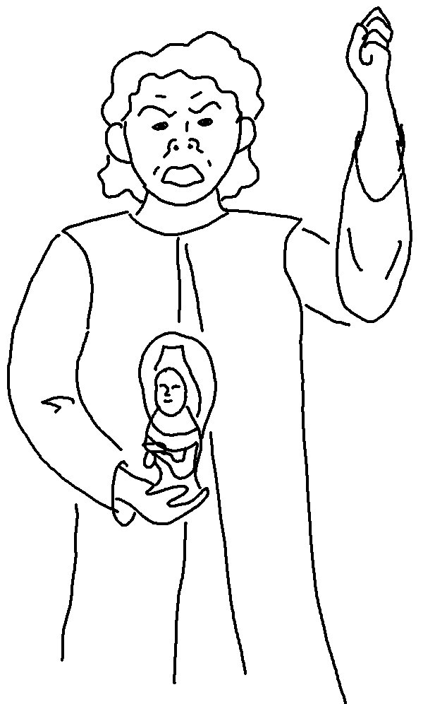
You must not make for yourself an idol of any kind. Exodus 20:4_{NLT}

